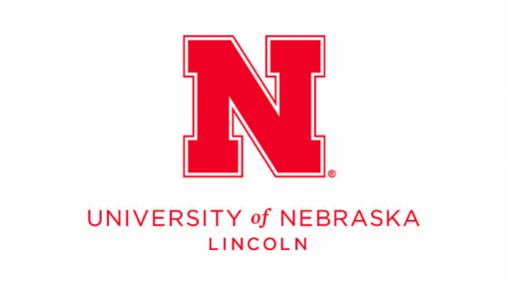
1-2 Fully Funded PhD Student Positions in Granular Mechanics
(Summer/Fall 2026)
About the Position
The Granular Mechanics for Energy and Disasters (GRAMED) Research Lab at the University of Nebraska, Lincoln (UNL) is seeking 1-2 fully funded PhD students to join in Summer or Fall 2026. The research topic will be relevant to fundamental and/or applied multiphase granular flow / subsurface geomechanics using computational and/or experimental approaches. The research is primarily related to geohazards and geo-energy. Interested candidates are encouraged to visit our lab webpage https://sites.google.com/view/yumeng-zhao to learn more.
Minimum Required Qualifications
- B.S./M.S. in Geotechnical Engineering, Civil Engineering or a closely related field such as Mechanical, Geological Engineering, Earth Sciences or Computer Sciences.
- Strong foundation in mechanics.
- Self-motivated, intellectually curious, and eager to learn and develop new research skills continuously.
Preferred Qualifications (one or more)
- Experience in numerical simulations (e.g., FEM, DEM, SPH etc.); open-source software experience is a plus.
- Programming skills (e.g., C++/Cuda-C++, Python, MATLAB) and/or familiar with Linux environments.
- Experience in statistical and data-driven approaches.
- Experience in advanced mechanical testing, such as indentation testing.
- Experience in experimental design and setup.
About the PI
Dr. Yumeng Zhao is an assistant professor in the Department of Civil and Environmental Engineering at UNL. He obtained his M.S. and Ph.D. degrees in Civil Engineering as well as his M.S. degree in Computational Science and Engineering, all from Georgia Institute of Technology. Before that, he holds a bachelor’s degree in Civil Engineering from Huazhong University of Science and Technology. His research focuses on using advanced computational and experimental approaches to study geosystems, including granular mechanics, multiphase flow, bio-geotechnics, energy-geotechnics and geo-hazards.
About UNL
UNL is the flagship public university of the state of Nebraska, USA. Established in 1869, UNL has a long-standing tradition of excellence in education and research and is classified as an “R1: Doctoral University – Very High Research Activity.” The Department of Civil and Environmental Engineering supports a wide range of research areas and fosters strong interdisciplinary collaborations.
UNL operates on a dual-city campus system. The main campus is located in Lincoln, the state capital, which offers a vibrant college-town atmosphere. The Peter Kiewit Institute (PKI) in Omaha hosts part of the UNL College of Engineering and is situated in Nebraska’s largest city, known for its dynamic urban lifestyle. Learn more about PKI at https://engineering.unl.edu/about/campuses-and-facilities/.
Dr. Zhao is based at PKI in Omaha and will frequently commute between Omaha and the main campus in Lincoln. Students are welcome to choose their primary locations, though PKI is preferred.
How to Apply
Please email to Dr. Zhao at yzhao52@unl.edu to express your interest in joining the lab with your CV and a brief research background and plan attached.

